**English lesson for cycle 3**

**(week 6)**

**CM2**

**Lesson 1**

* The flags (book, page 42-45)
* Learn and memorize the English-speaking countries and they flag (worksheet)

**civilization**

* The European union (book, page 46-48)

**Lesson 2:** Grammar

1. Nouns:
2. Verbs worksheet
3. Adjectives

**Lesson 3**

English comprehension (text)

* Text Sharon
* Text Ida

**Lesson 4**

* Universal values (book, page 50-51)

**Revision (oral and writing)**

* Numbers 1 to 30
* Days **of** the week
* Mouths of the year
* Time and the Date

Review the song what a beautiful name.

|  |
| --- |
| **Traduction en français**  **Leçon en anglais pour le cycle 3**  **CM2**  **Leçon 1**   * Les drapeaux (livre, page 42-45) * Apprendre et mémoriser les pays anglophones et les drapeaux (feuille de travail)   **Civilization**   * L’Union européenne (livre, page 46-48)   **Léçon 2**: Grammaire   1. Nom 2. Verbe feuille de travail 3. Adjectif   **Leçon 3**  Compréhension texte en anglais   * Texte Sharon * Texte Ida   **Leçon 4**  Valeurs universelles (livre, page 50-51)  **Révision (l’oral et écrit)**   * Nombre 1 à 30 * Les jours de la semaine * Les mois * L’heurs et la date   Revoir la chanson : What a beautiful name. |

Lesson 1

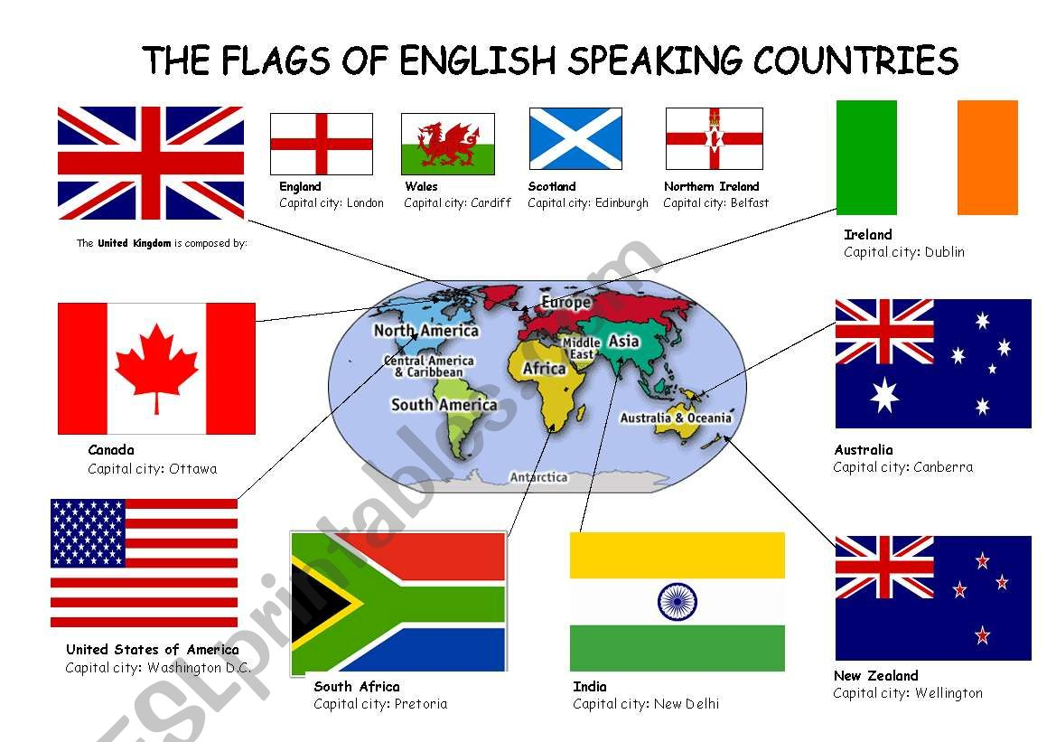

**Grammaire**

**Lesson 2 noun**

SENTENCE

A full sentence has a subject and a verb and expresse a complet thought.

A sentence starts with a capitale lettre and end with a fullstop,

Example: Juile ate an apple.

Juile is eating an apple.

NOUNS

A noun is a name that name anything person, places, thing,,animal or idea

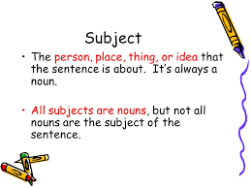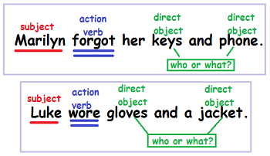

subject Nouns

The old, tired man is sitting under a tree and patiently waiting for his son to arrive.

verbs

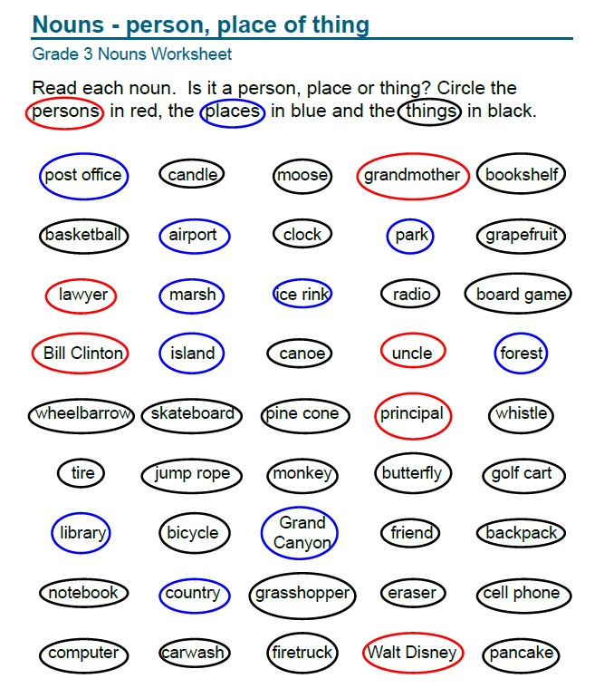

Lesson2

Name :

Date :

**Exercice 1**

**Nouns**

PUT THE NOUNS IN THE RIGHT BOX

|  |  |  |
| --- | --- | --- |
| **Person** | **Place** | **Thing** |
|  |  |  |
|  |  |  |
|  |  |  |
|  |  |  |
|  |  |  |
|  |  |  |
|  |  |  |
|  |  |  |
|  |  |  |
|  |  |  |
|  |  |  |
|  |  |  |
|  |  |  |
|  |  |  |
|  |  |  |

**Name:**

**Date:**

**Exercise 3**

**A noun is the name of a person, place, or thing. Read the words in the box.**

**Write them under the correct category.**

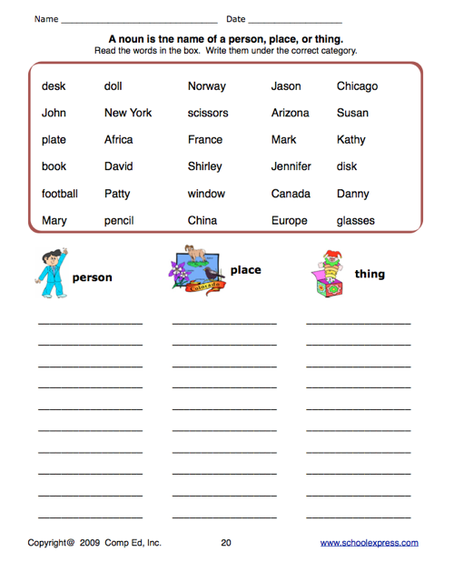

**Verbs**

**Lesson 2**

Verbs definition

Verbs are very important words we use verbs to say what people and things do. Verbs express an action. A physical action mental action or a state of being.

To find the verb in a sentence we ask the question what is the action.

|  |  |
| --- | --- |
| **verbs** | Walking walked will walk  Dancing danced dance will dance  I Began have begun I begin will begin    Sing smoke gave swim write  carry shut open jump wash  paint cook |

noun

Example: the woodcutter sat on the box. (what did he do?)

Verb

Verbs lesson 2

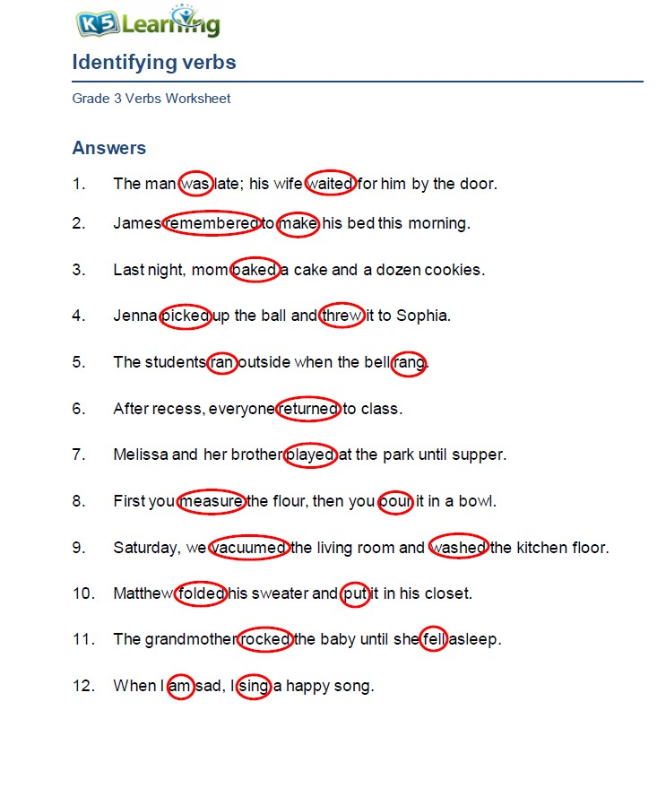

Lesson 2

Verbs worksheet

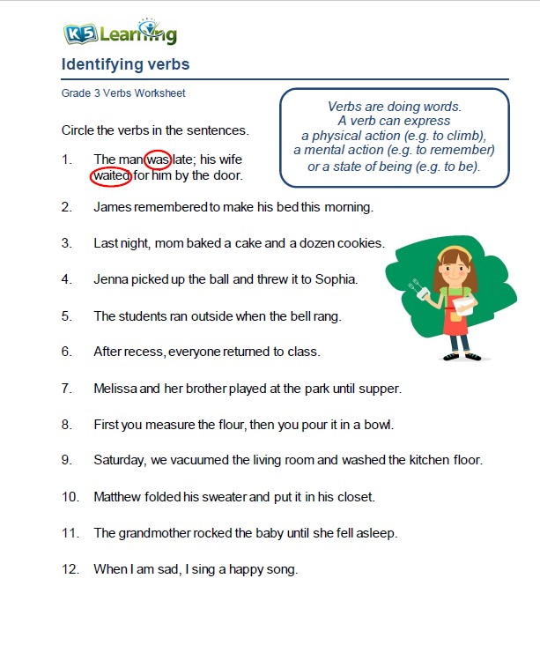

Write ten verbs in the box

|  |
| --- |
| **Verbs** |
|  |

**Adjective**

**Adjective definition**

Adjectives are words that qualifies/describe the noun.

We use an adjective with a noun to limit the meaning of the noun.

Example: if I say

Noun adjective noun

A man came into the room A thin man came into the room

|  |
| --- |
| Adjectives |
| A Thin man a fat man    An old book a new book    A heavy box a light box  Pretty new warm  long black good bad |

Adjective lesson

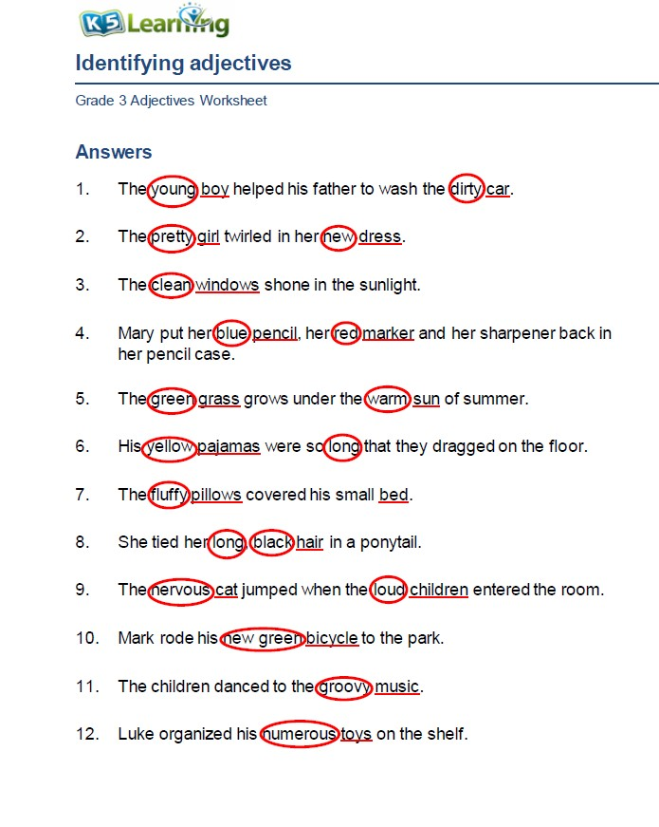

Adjective worksheet

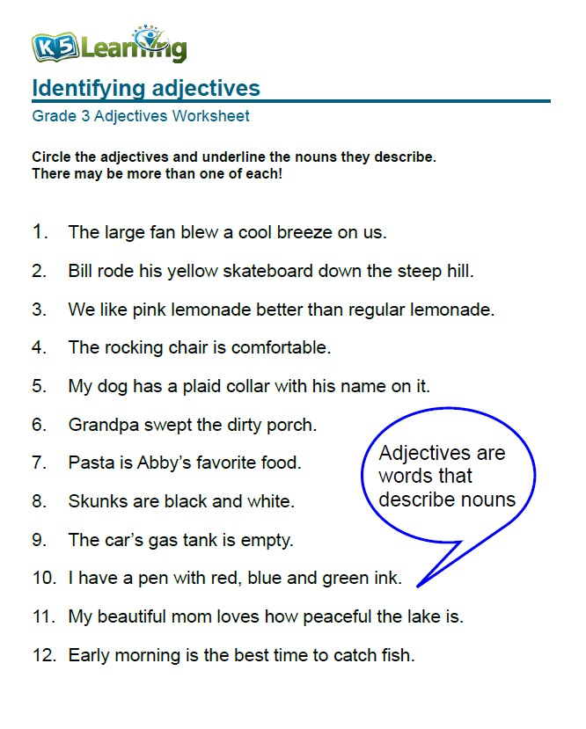

Write ten adjectives in the box

|  |
| --- |
| **Adjective** |
|  |

Lesson 4

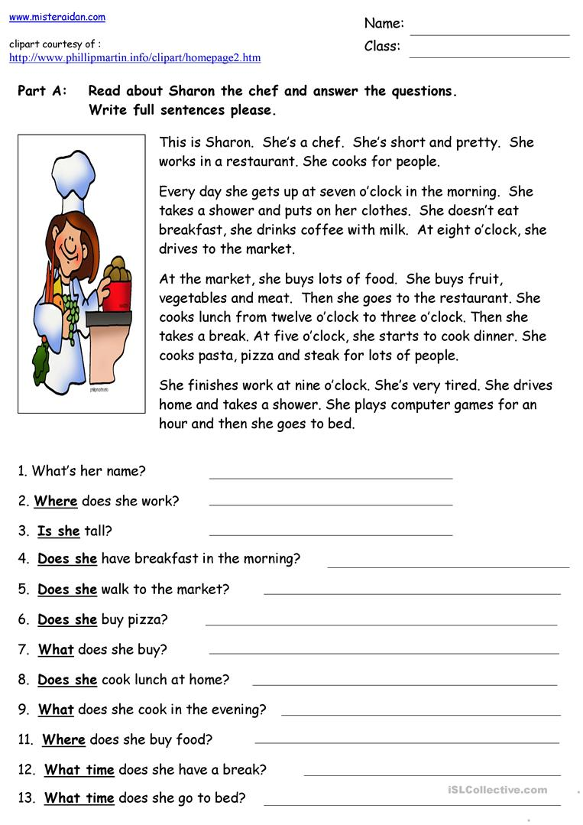

LESSON 4

